DISHES AND THEIR ALLERGEN CONTENT – THE HOMEMADE BREAD COMPANY LTD

DISHES | 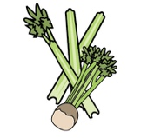 | 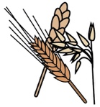 | 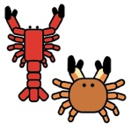 | 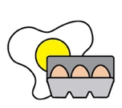 |  |  |  |  | 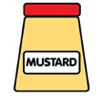
 | Celery | Cereals containing gluten | Crustaceans | Eggs | Fish | Lupin | Milk | Mollusc | Mustard | Nuts | Peanuts | Sesame seeds | Soya | Sulphur Dioxide
Mixed grain, brown bread |  | ✓
Wheat bread (white) |  | ✓
Peanut butter sandwich |  | ✓ |  |  |  |  |  |  |  |  | ✓
Cheddar cheese & pickle sandwich |  | ✓ |  |  |  |  | ✓
Tuna, sweetcorn, mayonnaise sandwich |  | ✓ |  | ✓ | ✓
Chicken, mayonnaise, salad |  | ✓ |  | ✓
Chicken, mango chutney & salad |  | ✓
Egg, mayonnaise & cress |  | ✓ |  | ✓
Hummus, tomato chutney and salad |  | ✓
Brie, rocket & avocado sandwich |  | ✓ |  | ✓

Review date: | 5.11.2019 | Reviewed by: | Renata Balch |  | You can find this template, including more information at www.food.gov.uk/allergy

